**Classification Algorithms and Results.**

The tables below show the results received when testing the algorithms used and their different scores in terms of Precision, Recall and F-Measure.

|  |  |  |  |  |  |  |  |
| --- | --- | --- | --- | --- | --- | --- | --- |
| Oversampling | | Positive Class (Risky) | | | Negative Class  (Non-Risky) | | |
| Algorithm |  | **Precision** | **Recall** | **F-Measure** | **Precision** | **Recall** | **F-measure** |
| Decision Trees | 36.1% | 53.1% | 43.0% | 96.1% | 92.4% | 94.2% |
| Neural network  (33 hidden units with 2 hidden layers) | 42% | 65.6% | 51.2% | 97% | 92.7% | 94.8% |
| Naïve Bayes | 7% | 57.8% | 12.5% | 92.1% | 40.1% | 55.9% |

|  |  |  |  |  |  |  |  |
| --- | --- | --- | --- | --- | --- | --- | --- |
| Normal results | | Positive Class (Risky) | | | Negative Class  (Non-Risky) | | |
| Algorithm |  | **Precision** | **Recall** | **F-Measure** | **Precision** | **Recall** | **F-measure** |
| Decision Trees | 0.519 | 0.319 | 0.395 | 0.949 | 0.977 | 0.963 |
| Naïve Bayes | 0.231 | 0.827 | 0.362 | 0.983 | 0.788 | 0.875 |

**Naïve Bayes example**

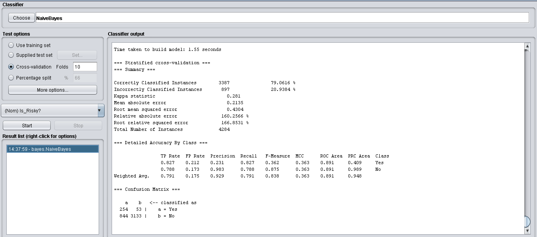

**Decision Trees example**

